|  |  |  |
| --- | --- | --- |
| **Work** | **Why- How** | **Code Example** |
| Data Types | to check the directory | ls |
|  | to create a folder | mkdir |
|  | to check in which folder we are in | cd |
|  | to Initialized empty Git repository in | git init |
|  | to check hidden git folder | ls .git |
|  | to check the status of the files in repository | git status |
|  | to add file in the directory | touch example.txt |
|  | To remotely add a repo in local terminal | git remote add (repo ssh) |
|  | to add file in staging area | git add example.txt / git add . |
|  | to commit | git commit -m "file name" |
|  | to go inside the file | vi example.txt |
|  | to come out of the folder | hit esc then shift: wq! |
|  | to check what is there inside the file/ check the content of the file | cat example.js |
|  | to remove the recent changes | git restore example names.txt |
|  | to create a branch | git checkout -b name |
|  |  | cd main directtory/folder/folder2 |
|  | to delete a file | rm Subjects.js |
|  | to Save changes in backstage working directory | git stash |
|  | to check the history of commits | git log |
|  | Push the changes to remote repo | git push origin /branchname/main/master |
|  | pulls the changes from remote repo | git pull |
|  | to find a txt file | dir *.txt |
|  | to come out of a txt file and save the content | esc - shift=colan wq! |
|  | find a txt file | grep -c "Elie" instructors.txt |
|  | to find a specific letter in the txt file | grep -ni "z.*" instructors.txt |
|  | Clone the Repo to local machine: | git clone https://github.com/user_name/repo_name.git |
|  |  | git fetch origin |
|  | Completely undo it, throwing away all uncommitted changes,  resetting everything to the previous commit: | git reset --hard origin/master |
|  | Undo the act of committing, leaving everything else intact: | git reset --soft HEAD^: |
|  | Undo the act of committing and everything you'd staged,  but leave the work tree (your files intact): | git reset HEAD^ |
|  | Move to branch: | git checkout branch_name |
|  | Switch back to local master so you can delete the local branch: | git checkout main |
|  | Delete local branch: | git branch -d branch_name OR git branch -D branch_name |
|  | Merge the branch with the local master: | git merge branch_name -m "comment" |

Difference Between Git Fetch and Git pull

|  |  |
| --- | --- |
| Git fetch | Git Pull |
| Git Fetch is the command that tells the local repository that there are changes available in the remote repository without bringing the changes into the local repository. | Git Pull on the other hand brings the copy of the remote directory changes into the local repository. |

Difference Between git and GitHub

|  |  |
| --- | --- |
| git | GitHub |
| Git is a distributed version control system for tracking changes in source code during software development. It is designed for coordinating work among programmers, but it can be used to track changes in any set of files. Its goals include speed, data integrity, and support for distributed, non-linear workflows. | GitHub is a web-based Git repository hosting service, which offers all of the distributed revision control and source code management (SCM) functionality of Git as well as adding its own features. |

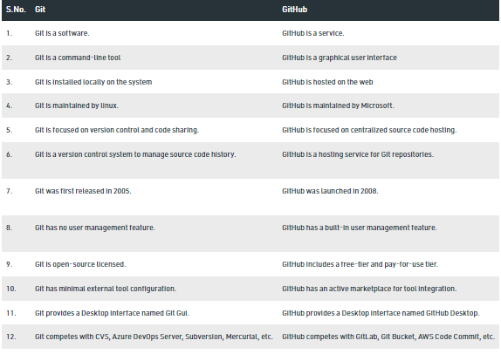

:

NOTE: Exit VIM if needed ctrl + c then type :qa! and push enter

NOTE: If file is not in local repo, manually move the file into

the correct folder (outside of console)

NOTE: If you need to hard reset your local repo to match

the remote master use the following commands: